Morning Prayer

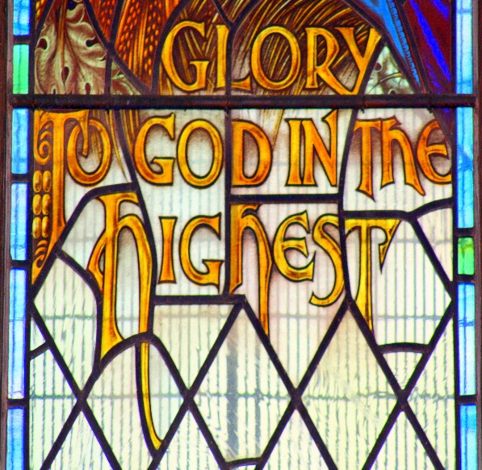

+ St. Matthew’s +
Parish of Edgeley and Cheadle Heath

You may wish to light a candle
and play some reflective music.

The Lord is good,
a strong refuge when trouble comes. God is close
to those who trust in him.
Nahum 1:7

Opening Sentences

O Lord, open our lips
and our mouth
shall proclaim your praise.

The night has passed,
and the day lies open before us;
let us pray with one heart and mind.

Pause for reflection
as you offer the day to God.
As we rejoice
in the gift of this new day,
so may the light of your presence,
O God, set our hearts on fire
with love for you; now and for ever. Amen

Bible Reading

You may wish to say Psalm 23
or the Psalm set for the day.

Psalm 23

¹ The Lord is my shepherd; ♦︎
therefore can I lack nothing.

² He makes me lie down
in green pastures ♦︎
and leads me beside still waters.

³ He shall refresh my soul ♦︎
and guide me in the paths of righteousness for his name’s sake.

⁴ Though I walk through the valley
of the shadow of death,
I will fear no evil; ♦︎
for you are with me; your rod
and your staff, they comfort me.

⁵ You spread a table before me
in the presence
of those who trouble me; ♦︎
you have anointed my head with oil
and my cup shall be full.

⁶ Surely goodness and loving mercy
shall follow me all the days of my life, ♦︎
and I will dwell
in the house of the Lord for ever.
Glory to the Father and to the Son
and to the Holy Spirit;
as it was in the beginning is now
and shall be for ever. Amen
You may wish to use pattern below or select the readings for the day.

Sunday

But now thus says the Lord,
he who created you, O Jacob,
he who formed you, O Israel:
Do not fear, for I have redeemed you;
I have called you by name,
you are mine.
When you pass through the waters, I will be with you;
and through the rivers,
they shall not overwhelm you;
when you walk through fire
you shall not be burned,
and the flame
shall not consume you.
For I am the Lord your God,
the Holy One of Israel, your Saviour.

Isaiah 43.1-3a
Monday

‘Do not let your hearts be troubled. Believe in God, believe also in me. In my Father’s house there are many dwelling-places. If it were not so, would I have told you that I go to prepare a place for you?
And if I go
and prepare a place for you,
I will come again and will take you to myself, so that where I am, there you may be also. And you know the way to the place where I am going.’

Thomas said to him,
‘Lord, we
do not know where you are going.
How can we know the way?’

Jesus said to him,
‘I am the way, and the truth,
and the life. No one comes to the Father except through me.’

John 14.1-6
Tuesday

Finally, beloved, whatever is true, whatever is honourable,
whatever is just, whatever is pure, whatever is pleasing,
whatever is commendable,
if there is any excellence and
if there is anything worthy of praise, think about these things.
Keep on doing the things that you have learned and received
and heard and seen in me, and
the God of peace will be with you.

Philippians 4.8-9
Wednesday

Let the word of Christ
dwell in you richly; teach and admonish one another in all wisdom; and with gratitude in your hearts sing psalms, hymns, and spiritual songs to God. And whatever you do, in word or deed, do everything in the
name of the Lord Jesus, giving thanks
to God the Father through him.

Colossians 3.16,17
Thursday

You are no longer
strangers and aliens, but you are citizens with the saints and also members of the household of God, built upon the foundation of the apostles and prophets, with Christ Jesus himself as the cornerstone.
In him the whole structure is
joined together and grows into a holy temple in the Lord; in whom you also are built together spiritually into a dwelling-place for God.

Ephesians 2.19-22
Friday

Let love be genuine; hate what is
evil, hold fast to what is good; love
one another with mutual affection;
outdo one another in showing honour.
Do not lag in zeal, be ardent in spirit, serve the Lord. Rejoice in hope,
be patient in suffering,
persevere in prayer.
Romans 19.9-12
Saturday

Jesus said to his disciples, ‘Therefore I tell you, do not worry about your life, what you will eat, or about your body, what you will wear. For life is more than food,
and the body more than clothing. Consider the ravens: they neither sow nor reap, they have neither storehouse nor barn, and yet God feeds them. Of how much more value are you than the birds!

And can any of you by worrying add a single hour to your span of life?
If then you are not able to
do so small a thing as that,
why do you worry about the rest?

Consider the lilies, how they grow: they neither toil nor spin; yet I tell you, even Solomon in all his glory was not clothed like one of these.
But if God so clothes the grass of the field, which is alive today and tomorrow is thrown into the oven, how much more will he clothe you - you of little faith!

And do not keep striving for what you are to eat and what you are to drink, and do not keep worrying.
For it is the nations of the world that strive after all these things, and your Father knows that you need them. Instead, strive for his kingdom,
and these things
will be given to you as well.

Luke 12.22-31
Prayers

Almighty and everlasting God, we thank you that you have brought us safely to the beginning of this day. Keep us from falling into sin or running into danger; order us in all our doings and guide us to do always what is righteous in your sight; through Jesus Christ our Lord.
Amen

Keep us, good Lord, under the shadow of your mercy in this time
of uncertainty and distress.
Sustain and support the anxious
and fearful, and lift up all who are brought low; that we may rejoice in your comfort knowing that nothing can separate us from your love in Christ Jesus our Lord. Amen

The Lord’s Prayer

Our Father in heaven,
hallowed be your name,
your kingdom come,
your will be done,
on earth as in heaven.
Give us today our daily bread.
Forgive us our sins as we
forgive those who sin against us. Lead us not into temptation
but deliver us from evil.
For the kingdom, the power,
and the glory are yours,
now and for ever. Amen

The Conclusion
The Lord bless us,
and preserve us from all evil,
and keep us in eternal life. Amen

Let us bless the Lord.
Thanks be to God.
Night Prayer

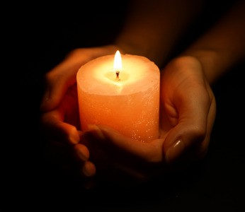

+ St. Matthew’s +
Parish of Edgeley and Cheadle Heath

You may wish to light a candle
and play some reflective music.

The eternal God is your refuge,
and underneath
are the everlasting arms.

Deuteronomy 33:27

Opening Sentences
The Lord almighty grant us
a quiet night and a perfect end. Amen

Our help is in the name of the Lord
who made heaven and earth.
Pause and reflect on the day that is past.

Save us, O Lord, while waking,
and guard us while sleeping, that awake we may watch with Christ and asleep may rest in peace.

Bible Reading

You may wish to say Psalm 91
or another chosen psalm.
Psalm 91

¹ Whoever dwells
in the shelter of the Most High ♦︎
and abides
under the shadow of the Almighty,

² Shall say to the Lord,
‘My refuge and my stronghold, ♦︎
my God, in whom I put my trust.’

³ For he shall deliver you
from the snare of the fowler ♦︎
and from the deadly pestilence.

⁴ He shall cover you with his wings
and you shall be
safe under his feathers; ♦︎
his faithfulness
shall be your shield and buckler.

⁵ You shall not be afraid
of any terror by night, ♦︎
nor of the arrow that flies by day;

⁶ Of the pestilence
that stalks in darkness, ♦︎
nor of the sickness
that destroys at noonday.

⁷ Though a thousand fall at your side
and ten thousand at your right hand,♦︎
yet it shall not come near you.

⁸ Your eyes have only to behold ♦︎
to see the reward of the wicked.

⁹ Because you have made
the Lord your refuge ♦︎
and the Most High your stronghold,

¹⁰ There shall no evil happen to you,♦︎
neither shall any plague
come near your tent.

¹¹ For he shall give his angels charge over you, ♦︎
to keep you in all your ways.

¹² They shall bear you in their hands,♦︎
lest you
dash your foot against a stone.

¹³ You shall
tread upon the lion and adder; ♦︎
the young lion and the serpent
you shall trample underfoot.

¹⁴ Because they have
set their love upon me,
therefore will I deliver them; ♦︎
I will lift them up,
because they know my name.

¹⁵ They will call upon me
and I will answer them; ♦︎
I am with them in trouble,
I will deliver them
and bring them to honour.

¹⁶ With long life will I satisfy them ♦︎
and show them my salvation.

Glory to the Father and to the Son
and to the Holy Spirit;
as it was in the beginning is now
and shall be for ever. Amen

You may use one of the following readings or choose a passage of your own.

Sunday

You, O Lord, are in the midst of us, and we are called by your name; leave us not, O Lord our God.

Jeremiah 14:9
Monday

Thus said the Lord God, the
Holy One of Israel: In returning and rest you shall be saved; in quietness and in trust shall be your strength.

Isaiah 30:15

Tuesday

Jesus said, ‘Come to me, all you that are weary and are carrying heavy burdens, and I will give you rest. Take my yoke upon you, and learn from me; for I am gentle and humble in heart, and you will find rest for your souls. For my yoke is easy, and my burden is light.’

Matthew 11.28-30

Wednesday

Humble yourselves under
the mighty hand of God, so that
he may exalt you in due time.
Cast all your anxiety on him, because he cares for you.

1 Peter 5.6,7

Thursday

Jesus said, ‘I have said this to you, so that in me you may have peace. In the world you face persecution. But take courage; I have
conquered the world!’
John 16.33

Friday

God has destined us not for wrath but for obtaining salvation through our Lord Jesus Christ, who died
for us, so that whether we are awake or asleep we may live with him.

1 Thessalonians 5.9,10

Saturday

Jesus said, ‘I am the
light of the world. Whoever follows me will never walk in darkness
but will have the light of life.’
John 8.12

Prayers

Merciful God, we entrust
to your unfailing and tender care
this night those who are ill or in pain, knowing that whenever
danger threatens your everlasting arms are there to hold us safe.
Comfort and heal them, and restore them to health and strength; through
Jesus Christ our Lord. Amen

Be present, O merciful God,
and protect us through the silent hours of this night, so that we
who are wearied by the changes and chances of this fleeting world, may rest upon your eternal changelessness; through
Jesus Christ our Lord. Amen

Visit this place, O Lord, we pray, and drive far from it the snares of the enemy; may your holy angels dwell with us in peace, and may your blessing be always upon us; through Jesus Christ our Lord. Amen

The Lord’s Prayer

Our Father, who art in heaven, hallowed be thy name;
thy kingdom come;
thy will be done;
on earth as it is in heaven.
Give us this day our daily bread. And forgive us our trespasses,
as we forgive those
who trespass against us.
And lead us not into temptation; but deliver us from evil.
For thine is the kingdom,
the power and the glory,
for ever and ever. Amen

The Conclusion

In peace we will lie down and sleep;
for you alone,
Lord, make us dwell in safety.

The Lord bless us
and watch over us;
The Lord make his face to shine upon us and be gracious to us;
The Lord look kindly upon us
and give us peace. Amen

Materials in this booklet are drawn from Common Worship: Services and Prayers
for the Church of England,
Common Worship: Pastoral Services, and Common Worship: Daily Prayer,
all of which are
copyright © The Archbishops’ Council
of the Church of England.

